Welcome to the University of Science and Technology.

In this handbook, you will find all you need to know at the beginning.

International Student Handbook
The School of International Education

主编 汤苏宁
副主编 许凡 冯峰 岳岩峰
编委 苗天宇 裴子慧 蒋梦笛
主编：汤苏宁
副主编：许凡 冯峰 岳岩峰
编委：苗天宇 裴子慧 蒋梦笛

University of Science and Technology Liaoning
International Student Handbook

Table of Contents
PART I STUDY AT THE UNIVERSITY
PART II DAILY LIFE

Registration 1
Students’ Arrival and Registration. 1
Student Card 1
The Lost and Found of Cards 2
Academic Guidance for Degree Students (English Instruction) 2
Credits 2
Attendance 2
Tests and Examinations 3
Examination Regulations 7
Academic Guidance for Degree Students (Chinese Instruction) 10
Academic Guidance for Language Students 17
Academic Dishonesty 18
Scholarships (TI) 19
Scholarship Accreditation 19
Scholarship Types 20
Qualifications and Conditions of Scholarship Selection 20
Time and Process 23
International Student Regulations (ISR) 24
International Student Credit Rating System (ISCRS)（TI） 33
Violations of ISR 34
International Student Dormitory Regulations（ISDR） 35
Graduation and Convocation 37
Probation, Suspension, Withdrawal and Restore 37
Suspensions and Restoration 37
Probation and Dismission 39
Withdrawal from the University 42
Visa and Student Residence Permit Application 42
Visas 42
Residence Permit Process: 42
Fees Schedule and Regulations 44
Fees Schedule: 44
Regulations: 45
Notification and Official Letters 47
Notification 47
Request for Leaving 47
Official Letters 48
Contacts 49
Appendix I: All related forms 50
Leaving Note 50
Agreement on Accommodation 52
Room Items List of Dormitory 56
Room Items List Of Dormitory（Single） 56
Application Form for Deferment of Examination 62
Application Form for Program-Transfer 64
Shopping 66
Meals 67
Living 68
Recreation and Sports 68
Travelling 76
Appendix II: Abbreviations 81

PART I
STUDY AT THE UNIVERSITY

Registration

Students’ Arrival and Registration.
After arriving at the University, students should go to room 203 of the school of international education for identity confirmation, then pay for the related fees. After obtaining the payment receipt, students should go to the International Student Affairs Office for the establishment of records and registration procedures, and receive further instructions and bedding.

Student Card
International student card is the identification of an international student. The University recommends that every international student takes great care of the card for it not to be arbitrarily altered or lent. The student card is firstly examined at the beginning of each semester, and no examined chapter is invalid. Students are required to carry students ' certificates in class.
The student smart card is an important card for students ' campus life, which can be used for Internet connection, book lending, canteen dining and campus supermarket shopping.

The Lost and Found of Cards
Once your student card or key card is lost, please report to the ISAO immediately. The University is not responsible for any lost caused by the missing of the cards.

Academic Guidance for Degree Students (English Instruction)

Credits
The number of credits assigned to a subject is indicative of the contact time with a teacher and/or the study time associated with that subject on a weekly basis over a period of one semester.
In general, a single credit represents attendance once a week throughout the semester at a lecture lasting 50 minutes. For field studies and laboratory classes, a credit generally represents at least two 50-minute sessions. Each credit presupposes an average of two hours preparation each week on the part of the student.

Attendance
Students are expected to attend all scheduled classes for which they have registered. If absence is due to conditions beyond their control and they wish to establish that fact in order to justify make-up work (e.g. papers, assignments), a written explanation together with supporting documents must be presented to the subject instructor for approval.
According to individual subject instructor's criteria, a student might be penalized for being absent without approval.
A student who is more than 15 minutes late for a class may be counted as absent. All unapproved absences will be counted.
Official leave of absence applies only to cases where the Academic Registrar has given specific written approval.

Tests and Examinations
Students should sit for all scheduled tests and examinations. A student failing to sit for a test or examination without official permission will be graded F for the occasion.
A semester or year examination will normally be required for a subject. In general, examinations are scheduled within the university examination period.
Subject instructors should follow the assessment method specified in the teaching plan. (For example, proportion of elementary results, satisfactory attendance rate, assignments, in-class quiz, etc.)
Eligibility to Sit for Semester Examinations
Only students whose names are on the subject enrollment record and whose attendance is satisfactory in accordance with the regulations are permitted to sit for the semester examination in the subject. The subject teacher has the absolute authority to cancel the student’s candidateship in subject examinations.
Application for Deferment of Examination
A student who misses an examination because of extenuating circumstances such as illness, injury or other personal emergencies may apply to the educational administrator for Deferment of Examination. Applications should be made within 5 working days after the mentioned examination. The student who receives an Approval of Deferment of Examination is permitted to be seated in a make-up examination (free of charge). If failed, NO FREE make-up examination is offered. The failed candidate of the make-up examination should pay for RETAKING the subject.
A student who misses an examination because of other personal reasons may apply to the educational administrator for Deferment of Examination (free of charge). Applications should be made at least 10 working days before the date of the mentioned examination. Without the Approval of Deferment of Examination, students should not be absent from the examination.
In case of illness or injury, the application should include a medical certificate completed by a qualified medical practitioner.
When students apply to the Academic Registry for Deferment of Examination or a free make-up examination, the following situations would normally not be considered valid:

a) Elective surgery scheduled to be held on an examination day;
b) Public examinations such as HSK, TOEFL, SAT, GRE, GMAT, etc., held on an examination day; or
c) Having forgotten or misread the examination schedule.
Make-up Examinations
The make-up examinations are held within the academic week zero of the following semester. Processing of Retaking and Downgrading, issued in the first academic week, are decided according to the results of make-up examinations.
Roll Processing
Every semester, for an individual student, if the number of the failed compulsory subjects in one semester reaches at 50% or above of the total number of semester subjects, a Letter of Warning is issued. If the number of the failed compulsory subjects in two successive semesters reaches at 50% or above of the total number of each semester subjects, a Decision of Degrading is issued. If the number of the failed compulsory subjects in three successive semesters keep at 50% or above of the total number of each semester subjects, the said student should withdraw from the university.
A student who is absent from an examination and does not apply for a make-up examination or whose application is disapproved, will receive zero marks for that examination and cannot be seated in the free make-up examination.
No fee will be charged for the first make-up examination of one subject.
For each subject, ONLY ONE free make-up examination is offered to the failed candidate of the examination. Regardless of the reasons for the absence, any student who is absent from the mentioned make-up examination should pay for retaking the subject.
Supplementary Examinations
All students, excluding final year’s students, are eligible for supplementary examinations.
The availability of a supplementary examination is subject to the recommendation of the Dean of Teaching
Failure in the retaking examinations may result in downgrading or WF (Withdrawn Failing).
Charges for Retake
Payment for retaking of one subject is charged according to the credits for the above subject. The highest recorded mark for a Retaking examination is 85.

Examination Regulations
USTL holds no tolerance for cheating in examinations. Students who cheat in an examination receive 0 as the result of the subject and are not qualified to apply for a Certification of Degree.
Students are not allowed to sit for an examination if they:
a) have not completed the proper subject/program enrollment procedures; or
b) have not satisfied attendance requirements because of excessive absence from class; or
c) have not settled any fees owing to the university.
Students should read the examination timetable carefully and take note of the date, time and venue of the examinations. Having forgotten or misread the examination timetable is normally not an acceptable excuse to apply for make-up examinations.
Students should arrive at the examination venue at least 10 minutes before the scheduled time of the examination, and be seated in accordance with the seat number assigned to them.
Students will not be allowed to enter the examination venue after the first 30 minutes of the examination.
Students are not allowed to leave the examination venue during the first 30 minutes and the last 15 minutes of the examination.
Students should bring their Student Card (or Identity Card) which should be displayed at the top right-hand corner of the desk throughout the examination. Students without any such identification may not be allowed to sit for the examination.
Unless otherwise approved by the Dean of Teaching, no cell-phones, books, notes or paper should be brought to the desk. Such items should be submitted to the Invigilator of the examination before the examination commences.
Students should remain absolutely silent throughout the examination and must not speak or do anything to disturb other students. If they have questions, they should put up their hands and wait patiently for an invigilator.
Students who wish to leave the venue during an examination session should:
a) first check the answer book(s) and papers that they bear their names, student numbers;
b) raise hand and wait for an invigilator;
c) leave only when the invigilator has signified his/her assent.
At the end of the examination, students should:
a) promptly stop writing and wait until the invigilator has collected all answer books;
b) leave only when the invigilator tells them to do so;
c) not remove anything from the examination venue except personal belongings.
Disqualification
A student who has committed any of the following offences is subject to disqualification in a subject or in the entire examination:
a) Copying other students' work or any form of cheating (for example, asking other students for answers, exchanging papers of examinations, showing one’s answers to other students, using references of other students in a A4-reference examination, etc.) inside or outside the examination venue;
b) Bringing unauthorized articles, for example, mobile phones, into the venue without permission;

c) Removing articles other than personal belongings from the examination venue;
d) Leaving the examination venue without permission;
e) Continuing to write after the end of an examination;
f) Disobeying instructions of an invigilator.
In addition, such cases will be submitted to the Committee concerned for further action.
A student who is absent from an examination without an acceptable excuse and proper documentation evidence will receive zero marks for that examination paper.

Academic Guidance for Degree Students (Chinese Instruction)
Foreign students are an important part of our students, and also an important part of our school. Our university is a university approved by the Ministry of Education with the qualifications of students. Schools with the right to confer doctorates, masters, and bachelor’s degrees can recruit and train foreign students. In order to standardize the teaching management of the foreign students in our school, we should improve the quality of the students coming to China, enlarge the popularity of our university in the world, and combine the actual situation of the school.
First Chinese foreign student is a foreign student who studies a PhD, Master's degree in Chinese, and has a unified class with Chinese students. In principle, Chinese foreign students ' teaching management and Chinese students ' assimilation, with the "university acceptance of foreign student’s management provisions", "on the general higher education to China's degree implementation of the Chinese students," and Liaoning University of Science and technology teaching management documents such as the basic basis.
Second All relevant departments of the school have the obligation and responsibility to the education of foreign students and educational work into the Department's overall planning, departments and colleges specific division of labor as follows:
1, International Institute of Education
(1) student enrollment promotion;
(2) To consult with graduate schools to determine the list of students enrolled in postgraduate degrees;
(3) Transfer the admission list of undergraduate students to the dean's Office;
(4) Admission and registration procedures for international students;
(5) Establish a school status;
(6) organize and develop foreign student training programs;
(7) The management, coordination and arrangement of the specific affairs of foreign students ' enrolment;
(8) provide degree certificates, transcripts, etc. for foreign students;
(9) the declaration of the Certificate of Completion (knot) industry;
(Ten) To assist the Graduate school and the academic office in the examination of Chinese qualifications for foreign students degree applications;
(one) the implementation of the language and culture courses for foreign students in charge of academic qualifications;
2, Graduate School
(1) the selection of tutors for postgraduate degree students and the catalogue of enrollment;
(2) assignment of teaching tasks and arrangement of instructors and instructors;
(3) Achievement Management for postgraduate degree students;
(4) The management of graduate students ' student status in China;
(5) Postgraduate degree in the organization of the accreditation of Graduates (knot) industry and degree;
(6) produce a transcript of a postgraduate degree abroad.
3 , Dean's Office
(1) Electronic registration of international students and establishment of electronic status;
(2) Bachelor's degree registration and performance management;
(3) Bachelor Degree in International Studies and degree awarding;
(4) A transcript of a bachelor's degree abroad.
4 , each teaching unit
(1) Student status management and performance management;
(2) the is responsible for arranging Chinese foreign students ' professional learning links, including classroom learning, outings, internships, graduation projects, etc., as stipulated in the training program;
(3) Professional Qualification audits in graduate admissions;
(4) The arrangement of postgraduate tutors, the formulation of learning plans and the implementation of teaching materials;
(5) Bachelor Degree students ' status is handled according to the requirements of the academic office, when the status changes should be reported to the School of International Education Records;
(6) The instructor in the class is responsible for the daily management of international students;
(7) to assist the School of International Education in assessing the annual scholarship qualifications of Chinese Government scholarship students;
(8) degree of graduation and accreditation of degree qualifications;
Third according to the national conditions and characteristics of the foreign students in the country where they are educated,
The supplementary provisions are as follows:
1, Bachelor's degree in foreign student training in accordance with foreign students training program;
2, The pass scores for each course are based on score (hundred);
3, you can bring a paper xx- Chinese dictionary when you test;
4, The instructor can adjust the assessment method and evaluation method according to the curriculum characteristics.
Fourth Workflow
1, Enrollment
(1) Graduate School to establish a professional catalogue of foreign student enrollment, to identify the professional and mentor who can recruit foreign students; The School of International Education organizes foreign student training programs and publishes them on the website every year 6 months.
(2) the School of International Education (HKIEd) plans and implements admissions programs based on graduate school admissions instructors, enrollment catalogues and training programs. The School of International Education, after first instance of a student's application, is referred to the Graduate school or the academic office, graduate school or the academic office and the relevant college for confirmation of the admission list and for filing, and the School of International Education for Admission and related formalities.
2, Teaching and Student status management
(1) foreign students are required to register at the School of International Education within a specified period of time; The School of International Education 2 weeks after each semester, the actual list of students will be submitted to the Graduate school and the Senate, Graduate school and the academic Office for registration.
(2) International Institute of Education is responsible for sending degree students to the relevant colleges for reporting, the College designated special personnel to help students to arrange classes, order teaching materials and other work, and complete the relevant forms of filling or registration, and submitted to the relevant departments.
(3) Elective courses in accordance with the curriculum of foreign students Training program implementation, by the foreign Affairs of the dean responsible for the checks.
(4) The Graduate school, the academic office and the relevant colleges organize the teaching links according to the Foreign Student training program;
(5) International students complete their studies on schedule and issue academic certificates to meet the requirements of the awarding degree, while awarding the corresponding degree. The diploma is reported by the School of International Education in accordance with state regulations (including photo collection), and the degree certificate is declared by the Graduate school and the academic office.
(6) students who need a one-year Chinese tutorial, who are temporarily in the custody of the School of International Education for the duration of the tutorial, will be allowed to move to the Graduate school or the academic office in order to avoid the Chinese language courses for degree courses, which may prevent them from attending the course.
These procedures are implemented from the 2016. If other relevant documents are inconsistent with these provisions, this provision shall prevail.

Academic Guidance for Language Students
International students must complete all the courses stipulated in the Teaching plan and pass the examination. The examination results are recorded in the "Term examination" performance registration form, signed by the instructor, and the Dean. as the original credentials of the students ' academic achievement.
The examination of each subject's achievement is composed of the final result and the ordinary result. Hundred score is used to evaluate the results of examination course. The examination class result is excellent, good, medium, pass, fail the record. Subject make-up exam results should be marked with the words.
International students should attend the classroom study, experiment class and practice stipulated in the Teaching plan on time. The instructor is responsible for attendance and record, as the basis for the attendance of international students. Students with academic qualifications in a single course more than One-third of the teaching hours of the course will be abolished the final examination of the course of the qualification; should not take part in the normal make-up test, must be rebuilt; If similar cases continue to occur, the School of International Education will recommend to schools that they do not graduate and do not issue Eighth international students may not be able to participate in the examination on a regular schedule, must apply to the Institute of Education in advance, after approval can be delayed. Without prior leave or leave without approval without permission to participate in the examination by the open examination.
Students fail the course every semester, there is a make-up exam. The make-up time is to be conducted a week before the commencement of the next semester. Those who fail the exam can be rebuilt. Ninth four-year students in the seventh semester (five-year system for the Ninth semester) of the course of the courses did not receive credits, the school arranges the retake at the beginning of the eighth semester (the five-year system at the beginning of the tenth semester), and the school arranges for the last retake of the course before the graduate qualification is approved. Tenth of the examination of the subject score 0, and not to participate in the normal make-up exam.

Academic Dishonesty
The University is strictly against plagiarisms of any kind. Hard work should not only be one’s attitude toward academic life but also the attitude toward life. Academic dishonesty once caught, will be seriously punished, in the worst-case scenario, one could be dismissed from the university due to academic dishonesty.

Scholarships (TI)
In order to attract more excellent foreign students to study at Liaoning University of Science and Technology, and also to encourage and recognize outstanding students who are outstanding in school and other aspects, according to the document spirit of relevant departments, Liaoning University of Science and Technology decided to set up a scholarship system for foreign students. The scholarship amount should in principle not exceed the 5%of the tuition fees paid by the students, and the number of students should not exceed the 10%of the number of foreign student in the year.

Scholarship Accreditation
Foreign Students Scholarship Accreditation Committee of University of Science and Technology Liaoning is the responsible organization of the International Student Scholarship Award. The committee consists of members from the international exchange and cooperation service, the School of International Education, the academic office and the relevant schools. Group members are tentatively 8.

Scholarship Types
There are three types of scholarships for foreign students: admission scholarships, academic scholarships and individual scholarships. Admission Scholarship is a one-time scholarship for students studying in Liaoning University of Science and Technology for the first time; academic scholarships are set up to reward and recognize students with excellent academic performance, and individual scholarships are intended for students who are outstanding in sports and cultural activities. (Details of the scholarship type are shown in the schedule)

Qualifications and Conditions of Scholarship Selection
1. Scholarship Candidate Qualification
Liaoning University of Science and Technology for foreign students scholarship candidates for the Liaoning University of Science and Technology, no disciplinary and bad credit records of foreign students with academic qualifications. Admission scholarships and scholarship scholarships are only for foreign students who have not received Chinese government scholarships and Liaoning provincial governments scholarships.
2. Scholarship Application and Selection Criteria
(1) Admission Scholarship: Students who have achieved excellent results in their schools before coming to China and who have reached level four through the Chinese Proficiency test (HSK) can apply.
★ Reach the level of HSK Four, can be eligible to apply for a third-class scholarship;
★ Reach the level of HSK Five, can be eligible to apply for second-class admission scholarship;
★ Reach the level of HSK Six, can be eligible to apply for a first-class admission scholarship.
(2) Academic Scholarship: Requires the applicant to have a good attitude to study, to complete the work conscientiously, the results of at least all qualified and no make-up examination records.
★ Third-Class scholarship must meet the average score of all subjects is not less than a score and a single score of not less than;;
★ Second-class scholarship must meet the average score of all subjects is not less than B score and a single score of not less than A;
★ A first-class scholarship to meet all subjects score is not less than score and a single score of not less than No..
(3) Individual scholarship: A student in a school who has outstanding performance in other areas except for study can apply for this award.
★ Third-Class scholarship awards are to participate in school-level or college-level competitions, activities to obtain a third-party;
★ Second-Class scholarship awards are to participate in school-level or college-level competitions, activities to obtain a second person;
★ First-Class Scholarship award object is to participate in school-level or college-level competitions, activities to obtain the number one person; The represents the college to participate in all kinds of competitions, activities and awards, can be directly identified as a first-class scholarship.
★ Individual Award Special Scholarship is specially awarded to those who represent the school to participate in the competition or activities at the provincial (city) level. The amount of the bonus is determined by the review Panel based on contribution and impact. Individual Award Special scholarship and individual award other kinds of scholarships do not have both.
The final candidates for the above awards should consider the proportion of students who meet the criteria and the number of students in the university. If the number of people who meet the conditions exceeds the proportion of those who should be awarded a scholarship, the panel shall have the right to compare and adjust other conditions in accordance with the actual conditions; in particular, the number of award winners can be adjusted according to the actual situation when the total bonus amount is unchanged.

Time and Process
1. Selection Time:
Scholarships for foreign students at Liaoning University of Science and Technology apply for an annual 7 month to the middle of the 8 month. The selection time is 8 , and the award time is the 9 month of the year, usually at the opening ceremony of the foreign students.
2. Selection Process:
★ Liaoning University of Science and technology scholarships for foreign students must be submitted by the students themselves to accept the application, the students who do not apply will not be eligible to participate in the scholarship selection;
★ Application materials will be submitted by the students to the international Exchange and Cooperation Office (International Institute of Education), by the International Exchange Office (International Institute of Education) submitted to the School Scholarship Evaluation Group, the final award in the form of a meeting;
★ The results of the selection, the international Exchange and Cooperation Office (International Institute of Education) will be publicized, the publicity period of 3 days. During the publicity period, students may lodge a complaint with the school if they disagree with the result.
★ The scholarship for international students of Liaoning University of Science and Technology is the annual scholarship. The school year is calculated by the 9 month of the year to the 8 month of the following day.

International Student Regulations (ISR)
Chapter I Guidance
In order to standardize the management of foreign students in our university, further develop the overseas students ' education in our school, according to the regulations on the administration of foreign students accepted by colleges and universities in accordance with the Ministry of Education, the Ministry of Foreign Affairs and the Ministry of Public Security.
Second This regulation is the basic regulation for the management of foreign students in schools, and is applicable to all colleges, departments, research institutes, study centers and other units affiliated to the school (hereinafter referred to as "faculties") Foreign students referred to, in these provisions, foreign nationals who are registered in our school with a foreign passport for a degree or a non-academic education.
Third, the basic principles of the management of foreign students in schools are: people-oriented, standardized and efficient, strict management, and actively and steadily promote the process of assimilation of Chinese and foreign students.
Chapter II Management System
Fourth, the School of International Education is the management department of foreign students in our school, under the leadership of the principal responsible for the education of students, management policy formulation, training guidance, implementation supervision and coordination of work.
Fifth, the School of International Education on behalf of the school coordination and Liaoning Province, the state-funded students, Anshan Municipal Public Security Bureau and other relevant departments related to the work of foreign students, accept its business guidance, do a good job in our school foreign Affairs management.
Sixth, the School Senate, Graduate school, student office, international Exchange and Cooperation Office, Security Service, logistics Management Office, Finance Department and other functional departments in accordance with the principle of convergence management, to deal with their respective areas of responsibility for foreign students, the School of International Education is responsible for coordination of work.
Chapter III category, enrollment and admission of foreign students
Seventh, schools provides academic and non-academic education for foreign students. The categories of students with academic qualifications are: undergraduates, postgraduates and doctoral students, and those who receive non-academic education are: Language learning and exchange students.
Eighth, the School of International Education is the centralized management department for the recruitment of various foreign students in our school. The departments and academic departments, graduate schools and the School of International Education should actively cooperate to do a good job in the student enrollment program, recruitment publicity, examination and so on.
Ninth, admission of foreign students to the school program, the Non-academic program is set up annually by the School of International Education, the President of the Office of the Conference after the implementation of the review.
Tenth, the School of International Education should publish the enrollment method and the Constitution in time, and actively organize the publicity of foreign enrollment. Departments can also through their own channels, and actively carry out publicity, in the coordination of international exchanges and cooperation to attract foreign students to study in our school, learning. The acceptance agreement between the departments and the overseas students must be reported by the International exchange and Cooperation Department, and all kinds of students must accept the admission formalities through the School of International Education.
11th, the admission criteria for all types of international students are determined by the Institute of Education in conjunction with relevant faculties and academic offices and graduate schools. The School of International Education is responsible for the examination, organization of examinations, assessment, or interview, acceptance procedures, and issuance of admission notices.
12th, departments should give priority to receiving foreign students enrolled in the program (including "Chinese Government scholarship" students, school exchange students and other foreign students sent by other government and higher authorities), and actively recruit students who are at their own expense and exchange student in the department.
13th, The specialty of accepting foreign students in the faculties should be open to the outside. For foreign students to set up a new professional education, must be through the relevant departments of the school for approval.
Fourth Chapter Scholarship System and international student funding management
14th, the Chinese government has set up a "Chinese government scholarship" for foreign students to study in China. The Treasury is responsible for the management of the funds in accordance with the relevant national documents. The School of International Education is specifically responsible for the use and distribution of the funds.
15th, schools set up "Liaoning University of Science and technology scholarships for foreign students" to encourage students in the school to strive for progress. The School of International Education has enacted a scholarship to implement the regulations and specifically manage the distribution.
16th, the School made "Liaoning University of Science and Technology on foreign students funds management measures", standardize the management of foreign students.
Fifth Chapter Teaching Management
17th, teaching management of foreign students according to the management of Chinese students, undergraduates are managed by the Dean's Office in accordance with the Compendium of Management regulations and implementing methods of undergraduates in Liaoning University of Science and Technology The students of non-academic education shall be administered by the School of International Education separately.
18th, each department shall, according to the academic office and the unified Teaching and learning program of the Graduate school, arrange for the study of the foreign students studying for the degree, and carry out the teaching activities in combination with the psychological and cultural characteristics of the foreign students. Under the premise of ensuring the quality of teaching, it is possible to adjust the program of foreign students ' reading. According to the requirements of the students themselves, the education program of non-educated students are developed by each receiving unit. The School of International Education for foreign students in our school of non-academic education coordination and management body.
19th, all types of students who are in school or are rewarded or punished, the management departments shall promptly report to the School of International Education. The School of International Education informs the relevant departments and the relevant national embassies and consulates according to different circumstances.
20th, the specific implementation of the rules of the "Liaoning University of Science and technology international students credit rating system (ISCRS)".
21st, public services, such as the school library, should provide foreign students with the same learning conditions and services as Chinese students according to their teaching needs. Foreign students who use other equipment and obtain other materials outside the teaching plan shall apply for approval by the school in accordance with relevant regulations and procedures.
22nd, each faculty organizes foreign students to conduct teaching practice and social practice, which should be carried out in accordance with the teaching plan with the Chinese students in the school, but in choosing an internship or practice place, the relevant foreign regulations shall be complied with, allowing the students to return to their internship and formulate corresponding supporting measures.
Sixth Chapter student work and life management
23rd, schools accept foreign students should be educated and managed in accordance with relevant laws, regulations and rules of the school. We should teach foreign students to obey the law and respect our social morality and customs.
24th, schools generally do not organize foreign students to participate in political activities. The School of International Education should organize the voluntary participation of foreign students in a number of activities to understand China's social and historical culture and to facilitate physical and mental health. Chinese and foreign students are encouraged to participate in various sports competitions and literary activities organized by the school.
25th, schools allow and encourage foreign students to join student associations and participate in activities. With the approval of the School of International Education, foreign students can set up a fellowship group within the school and act within the scope of our laws and regulations, subject to the leadership and management of the school. Foreign students shall be set up to apply to the competent authorities of the Chinese government for the establishment of schools and cross-regional organizations.
26th, schools respect the national customs and religious beliefs of foreign students, but do not provide a place for religious ceremonies. Missionary activities and religious gatherings are strictly prohibited in the school.
27th, foreign students in the campus of Shing, fights, traffic accidents and other general emergencies by the School Security Office in conjunction with the School of International Education; Such general emergencies occur outside the Department of International Education to assist the local police. Major events occurred in the departments should promptly report to the School of International Education in coordination with the municipal foreign affairs, public Security and other relevant departments.
28th, the School provides foreign students with accommodation in international students ' apartments, and the institute supervises and coordinates the work. International students should abide by the accommodation management rules for international students ' apartments. According to the "Ministry of Education, the Ministry of Foreign Affairs, the Ministry of Public Security," the command foreign students can stay outside the school, but should be in accordance with the provisions of outside registration procedures.
29th, the International Education Institute is responsible for foreign affairs management such as the entry and exit of students and their stay in China. All the foreign students who come to our school must apply for the entry of Foreign Student visa application form (JW202 or 201 table). For foreign students with tourist visas and other types of visas, the School of International Education will decide whether or not to convert their study visas.
Seventh Chapter
30th, matters not provided for in this Ordinance shall be in accordance with the education law of the People's Republic of China, the higher Education law of the People's Republic of China, the Law on the Administration of aliens ' entry and exit from the PRC, the administrative regulations on acceptance of foreign students by institutions of higher learning and other relevant laws and regulations and our school regulations.
31st, this Ordinance shall enter into force from the date of promulgation. This Ordinance shall prevail in the case of other students ' documents of the school which are inconsistent with this ordinance.

International Student Credit Rating System (ISCRS)（TI）
At the beginning of Spring semester of 2018, the School of International Education introduces a brand-new evaluation system called “International Student Credit Rating System” the ISCRS to track the performance of each and every international student. The System is design to monitor the daily behavior of the individual it transfers the performances of an individual into increment or decrement in scores. Each student at the beginning of a new academic year receives a total score of 100. Every violation of ISR or ISDR will result in a decrement of the total score, on the contrary, good works will result in an increment of the total score. Therefore, the final total score is not limit to 100 in the case that some of the students make no violations but only good works, the total could add up to more than 100 for example someone may end up with 120 scores at the end of the academic year.
The score increases or decreases in 5 scores each time a good work or violation is taken into account. Student should keep in mind that only with a total score above 90 is eligible for scholarship consideration of the same academic year.
However, student should also keep in mind that 5 scores is the minimum unit of increment or decrement in scores. The total increment of decrement associated with the actual event will be decided base on the situation of the scenario.
The School is constructing an online system which will make the ISCRS accessible to all students and staff so that everyone in the school can log in to the system with their own ID and pass word to track their own performance. The total score will be the most important piece of supporting evidence for any award or sanction to be made to or against the student.

Violations of ISR
The students who have made mistakes are given critical education or disciplinary action depending on their circumstances. The punishment is divided into: warning, serious warning, demerit, detention and dismissal. 33rd a student who makes a mistake has the right to plead, complain and retain different opinions, the school has the responsibility to review the complaint. Students who are subject to detention for disciplinary action may be relieved of disciplinary action if they have marked progress in performance. The probation period is one year, the graduating class student must not be less than three months. Students who are not repentant can be dismissed from the school.

International Student Dormitory Regulations（ISDR）
- International students should abide by the regulations of the school dormitory management, and respect the rest habits of other students.
- for first-time freshmen, in order to ensure their own and property safety, require at least one year in the school's student residence. A year later, if the students for the necessary reasons, can apply for living Off-campus: 1. Apply for Off-campus residence must fill out the "Overseas Student Accommodation Application Form", the submission of rental contract, homeowner ID card copy, the owner of the commitment, etc., after the College of International Education approved, can live outside the school. 2. After receiving the registration form for foreigners, we must go to the local police station in the housing jurisdiction to transact the registration and approval formalities. 3. If they do not comply with the above provisions, without authorization to live outside the school, their own commitment to all possible consequences.
- Students who live in the student's apartment in the school can choose either single or double room according to their own economic situation, and students who enjoy the scholarship of Chinese government and Liaoning province should be subject to the school arrangement (if they live off-campus, all expenses are paid for themselves).
- Students residing in the international students ' apartments should abide by the following provisions: 1. The school generally does not provide the couple accommodation conditions; 2. Shall not use electric stove, electric heating, toaster and other overload electrical appliances, not in the dormitory room cooking; 3. Keep the dormitory clean, pay attention to save water and electricity; 4. Keep the dormitory quiet, do not drink alcohol, not loud noise, do not put loudspeakers, so as not to affect others learning and rest; 5. No damage, unauthorized demolition, modification of the dormitory equipment. Damage, loss of property at the price of compensation.

Graduation and Convocation
Students with formal status, complete all the courses stipulated in the Teaching plan, pass the examination, and grant graduation certificate.
Failure to pass the exam, first issued a certificate of completion. Obtain a certificate of completion of a year to apply to the school retake, the examination of the students to renew the certificate. Failing courses are no longer given the chance to take make-up exams.
Students accumulated in the past years failed courses (failed to meet the requirements of the number of repeaters), the school will be arranged during the school study in batches to retake. If there is no time in the semester to schedule a retake, before graduation, before the test, overdue or after the test is still failing, issued a certificate of completion.

Probation, Suspension, Withdrawal and Restore

Suspensions and Restoration
One of the following circumstances shall be suspended:
1. By the school designated hospital for diagnosis, due to disease need to suspend treatment, recuperation time accounted for a semester of more than one-third people;
2. For special reasons, I apply or the school considers it necessary to break the scholar. Note: The period of suspension is generally not more than one year, cumulative not more than two years (due to illness by the school approval, can be suspended for two years). Students who have suspended their status or remain in school are not allowed to transfer to other schools or engage in other activities which are not in conformity with their status. Students for some reason to suspend, but do not meet the conditions of suspension, by my application, school approval can be retained for one year. The retention of school status and do not have to resume the procedure, cancellation status.
In case of injury
Students should provide the School with valid prescriptions from recognized hospitals to request temporary leave from the University.
Returning to study
The expiration of the period of suspension, should be held before the beginning of the term of the school to apply for a resume, the school approved by the original professional in the next grade.
One of the following circumstances shall be expelled from school: 1. Regardless of the reasons (including suspension and retention status), the study time in schools has reached eight years; 2. The expiration of suspended suspension of school proceedings; 3. After the reinstatement of the review unqualified no scholars; 4. I apply to transfer or drop out of school, after persuasion and education invalid; 5. Persons who have suffered serious illnesses by physical examination shall be expelled from school in accordance with the relevant provisions of the Ministry of Educational.

The aftermath of school drop-out, according to the following approach: 1. Students who drop out of college are issued with a certificate of withdrawal and issued certificates based on their study years and grades (at least six months after the completion of the examination results). Students who leave school without the approval of the school or suspend their schooling are not issued with certificates of completion or withdrawal. 2. No student who has been cancelled or dropped out of school shall apply for reinstatement.

Probation and Dismission
The following activities listed could result in Probation, or dismission of students from the university:
1. Violating the provisions of Chinese law, endangering national security, seriously undermining social order and the interests of others;
2. Destruction of public property and theft of property causing serious loss and harm;
3. Petty theft, fighting, repeated, bad conduct, moral corruption;
4. Those who violate the school discipline are extremely serious;
5. Arrears of tuition fees or boarding fees, and repeated reminders are still unable to pay for the total.
The punishment for the expulsion of students, by the school of International education, approved by the school, the cancellation of their residence permit or shorten the duration of residence in China and reported to the superior authorities for the record. Students who have been expelled from school are not issued with any academic certificates.
The student holds the large-scale assembly, the procession, the demonstration and so on the activity, must obtain the approval according to the legal procedure and the related stipulation. For those who have not been approved, the school shall be discouraged or stopped by law.
A student must abide by the relevant provisions of the State and school on the use of the network, not to log on illegal websites and the dissemination of illegal text, audio, video materials, etc., shall not fabricate or disseminate false, harmful information, no attack, intrusion into other people's computer and mobile communication network system.
Of the rules and regulations of the law, one of the following circumstances, and the consequences of a minor harm, can be lighter, mitigated or exempted from disciplinary action: (a) after the violation of the initiative to admit mistakes, check the understanding of profound, there is repentance performance; (b) The disciplinary offence is caused by other people's coercion or deception, and I can actively prosecute the disclosure, active cooperation with the school investigation, admit the attitude of good; (c) Other circumstances which may be lighter or mitigated.
If one of the following circumstances violates the rules and regulations of the school, the punishment should be heavier or heavier: (a) The wrong attitude after the disciplinary violation; (b) Having been disciplined and subjected to disciplinary action again; (iii) Collusion with persons outside the school discipline; (iv) The principal elements of group discipline; (e) Having a variety of disciplinary acts at the same time; (vi) Other circumstances from which heavier and heavier sanctions should be imposed. Because the student violates the discipline to the collective or other people to cause the economic loss or the injury, the discipline student damages, undertakes the medical expenses and so on.

Withdrawal from the University
Students have the right to withdrawal from the University upon personal reasons. However, the application process would take up to three moths to complete. Please be aware of the processing time and make your plans accordingly.

Visa and Student Residence Permit Application

Visas
A valid Chinese Visa is the key for you to enter the country. You are only going to obtain the visa of student type (X, according to the label) at any Chinese Embassy or Consulates outside the country with all other paper works ready.
The authorities dealing with residence, tourism and immigration formalities is Anshan Public Security Bureau entry-Exit Management Department.

Residence Permit Process:
1. After arrival at school, the international students must check in 24 hours, and within 30 days, under the guidance of international students, "resident aliens residence permit";
2. The extension of residence permit should be extended to the International Student Office within 30th of the expiration date. The public security organs will be punished according to the regulations (a fine of 500 RMB per day);
3. Passport, residence permit should be properly kept, if there is lost, should be timely to the instructor and the Public Security Bureau reported missing and procedures for the replacement;
4. International students should submit their written application to the International Students ' Office 10 days in advance for their illness, returning to other countries or holidays, and travelling to Hong Kong, Macao and Taiwan.
5. Foreign students to China's non-open areas of investigation, visit or travel, must be approved by the school and the relevant departments, and the school issued a certificate or I apply to the public security organs for travel permits;
6. The various visas, documents shall not be altered, damaged, the offender in accordance with the provisions of punishment;
7. Graduates or graduates of international students should leave the residence permit within the validity period and give the residence permit to the frontier checkpoints.

Fees Schedule and Regulations

Fees Schedule:
Price List
Item | Amount
Tuition Fee（one year） | ¥ 17,000 (Degree Student)  ¥ 12,000 (Language Student)
Accommodation Fee（one year） | ¥ 8,500 (Single Room)  ¥ 6,000 (Double Room)
*Physical Examination Fee  （every VISA renewal time） | ¥ 337
*Residence Permit for Foreigners  （every VISA renewal time） | ¥ 415
Insurance Fee（one year） | ¥ 800
Accommodation Deposit  (new student) | ¥ 700
Bedding Fee (new student) | ¥ 350 (Single Room)  ¥ 300 (Double Room)
Note: The fees marked with * are not collected by the university. They shall be paid to the related departments by students in person. These departments are the Enter-exit Inspection and Quarantine Bureau of Anshan and the Division of Exit-entry Administration of the Public Security Bureau of Anshan.

Regulations:
- In accordance with the relevant provisions of the State, the students to collect tuition fees, accommodation fees and other fees, all types of students should be proactive payment. Failure to pay tuition fees and not to register for slow payment formalities. Non-registrant can not participate in school-arranged teaching activities, can not use the school teaching resources. If the actual reason can not be paid on time, should be handled to suspend school, raise funds. Raise tuition fees and resume school. Graduates who have not paid their tuition fees will be kept by the college for the time being. S
- Students can use bank remittance, credit card, cash payment. The new payment period is two weeks prior to the report and two weeks after the date of enrolment, and the deadline for student payment is one months before the end of each semester.
- In the school period, the boarding student should pay the lodging fee in full according to the actual accommodation standard according to the semester or the school year. 1. The students who apply for lodging or graduate in advance, pay the accommodation fee according to the actual number of months, less than a month, according to one month’s calculation. 2. Students in the school period, for personal special reasons need to return or adjust the dormitory, should be timely approval and adjustment procedures, and in accordance with the provisions of the cost of lodging and adjustment. 3. Students leave home, halfway break, go out to practice, etc., need to retain the dormitory, as usual charge of lodging, otherwise need to apply in advance, and empty the dormitory items. 4. After the completion of the Off-campus accommodation procedures or the return of the graduates need to return the hostel deposit, the need to pay door card and deposit receipts, and the inspection of the dormitory without damage to the goods can be refunded. If any items are damaged or lost, pay the price list.
- The students in the school period, according to the provisions of other contributions should be paid: such as rehabilitation fees, replacement student card, campus card fees. Students who have been suspended from school (including those who retain admission), the fees paid are not refunded in principle and are subject to the actual cost of the school year upon return. The student who has received the payment receipt is required to return the payment fee, and the school will issue the receipt again according to the actual payment amount. Students who are expelled from school discipline are not refunded the tuition fees and accommodation fees paid.

Notification and Official Letters

Notification
The School and University notifications are delivery via three ways of communications to make sure the massages reach the target population.
You will be notified by the following two ways for the same massage:
- Wechat
- Written notification to be hung at the ISD lobby
Private massages or notice will be delivered or communicated directly via emails or phone calls.

Request for Leaving
Student should attend all the activities arranged by the school on time. International students to attend classes, internships or other unified activities should be strict attendance, no reason absent, late or early leave, for reasons cannot be participants must go to the counselor teachers to take time off. 1, sick leave: Students cannot attend classes due to illness, internships, more than three days must have or supplement the hospital's diagnostic certificate. One week or more, the president must sign the approval. In addition to emergency, the patient should be asked to leave in advance. 2, leave: Leave to apply in advance, three days (including three days) above, the President must be signed. Any person without leave, leave is not approved or more than the holiday, all shall be regarded as truancy. For truancy students according to their circumstances and attitude, they will get criticism or serious warning even the dismissal as punishment.

Official Letters
Any request for official letters should be first forwarded to the International Student Affairs Office.
Students have to right to ask the School to issue official letters for them base on the actual situation or status they possess. The school have to right to ask and check the validity of the situation or status proposed. Once the official letter is agreed to be issued, the student affair office will issue directly or, if not possess the authority, direct the international students to the related office, or department.

Contacts
The General Office of the School: (0412) 5929234
International Student Affairs Office: (0412) 5929285
University Emergency: (0412) 5928110
Student Emergency Contact: 15504120078

Appendix I: All related forms

Leaving Note
留学生请假条(原件)  Note for Leave (original) |  | 留学生请假条  Note for Leave
姓名  Name | 起止时间 Duration | 姓名Name | 起止时间  Duration
事由 Reason for Leaving |  | 事由 Reason for Leaving
学办负责人签字：
学院负责人签字：  （7天以上）  辽宁科技大学国际教育学院  School of International Education USTL |  | 辽宁科技大学国际教育学院  School of International Education  USTL

Agreement on Accommodation
Welcome to our foreign students’ apartment building of University of Science and Technology Liaoning. In order to obey the accommodation regulations, there is an agreement on accommodation between School of International Education (Part A) and International Student (Part B):
Ⅰ、Deposit
If “Part B” lives in the dormitory should pay RMB500 for deposit of the room and RMB200 for deposit of the smart card and the room rent for one semester or one academic year. “Part B” will get his/her deposit while checking out according to the receipts.
Ⅱ、 Public property
1、”Part A” will provide some room equipments such as key, bed, wardrobe, writing desk, chair, air-conditioner, remote controllers and so on. It is not allowed to move the furniture. If any damage or loss happens, you have to compensate the loss or damage according to the price list.
2、If there is any damage or loss on public property done by “Part B”, such as the laundry, kitchen, fire equipments and so on, he/she also will have to compensate the loss or damage.
Ⅲ、Electric appliance using and Safety check
1、To use in the room high power electric appliances such as heater, electric blanket , electric iron, electric oil radiator and so on is forbidden. If ”Part B” still does it, he/she will get the punishment as “confiscating the electric appliances or fines“. Changing the position of wires and throwing cigarette butts freely is also forbidden. If” Part B” still does it, he/she will get the punishment.
2、”Part A” will conduct the safety check casually every month, which should meet your positive cooperation.
3、It is forbidden to make noise, drink alcohol, and brawl, violator will get punishment.
Ⅳ、Room arrangement
1、”Part B” who choose double room should agree with the arrangement about his/her roommate, then tolerate each other. If there is any damage or loss on room’s property, they should reach an agreement on the compensation.
2、If “Part B” wants to change the room, he/she should apply to the International Students Affairs Office, and after getting permission, he/she can do it. If “Part B” wants to live outside, he/she should fill in the registration form for international students living off campus, from the International Students Affairs Office. If “Part B” wants to continue to study and live in the apartment, he/she should book the room in the last semester.
Ⅴ、Payment
1、“Part B” shall pay the room rent on time.
2、“Part B” should pay the electricity fee on time.
Ⅵ、Closing time
From Sunday to Thursday 11:00pm
Friday, Saturday and holidays 12:00pm
Visitors are not allowed to stay after the closing time. If ”Part B” accommodates a guest for the night in the room, he/she will get the punishment.
Ⅶ、Check- out
“Part B”, except those who paid the tuition for the next semester, should check out in 30days after the graduation ceremony. When leaving, “Part B” should notice “Part A” for 2-3 days earlier.
Ⅷ、”Part B” will get the punishment as a “warning” or can’t continue living in the room if he/she disobeys the accommodation regulations. The way how he/she follows the regulations on accommodation can be one of the factors of scholarship assessment.
Ⅸ、This agreement shall be held in two copies of the same form, and shall come into force as from the date when both Parts sign on the agreement.

Room Items List of Dormitory
留学生公寓物品详单（单人间）

Room Items List Of Dormitory（Single）
请相关人员查看好物品数量及状态，在学生入住及离开时，学生和宿舍管理人员共同清查。
Please check the room items' quantity and status. When students check in and check out, teacher and students will check up together.
序号No. | 项目  Room items | 数量 Quantity | 单价Price | 入住时状态  Status of check in | 备注  Memo
1 | 桌子（含书架）  Desk（with bookshelf） | 1 | 2200.00
2 | 椅子 Chair | 1 | 340.00
3 | 立柜 Wardrobe | 1 | 2300.00
4 | 床（带床头、床垫）  Bed (with headboard and mattress) | 1 | 1950.00
5 | 空调 Air-condition | 1 | 2010.00
6 | 空调遥控器  Air-condition remote control | 1 | 150.00
7 | 窗帘 Curtain | 1对 | 600.00
8 | 电子门钥匙  Electronic door key | 1把 | 200.00
9 | 床头柜 Bedside cabinet | 1 | 490.00
10 | 门玻璃 The glass of door | 2面 | 200.00
11 | 纱窗 Gauze-window | 2扇 | 200.00
12 | 鞋柜 Shoes cabinet | 1 | 300.00
13 | 门（含玻璃)  Door(with glass) | 2扇 | 1000.00
卫生间 Bathroom
14 | 镜子 Mirror | 1 | 700.00
15 | 洗手盆 Lavabo | 1 | 1000.00
16 | 水龙头 Water faucet | 1 | 500.00
17 | 抽水马桶 Flush toilet | 1 | 1000.00
18 | 毛巾架 Towel rack | 1 | 500.00
19 | 淋浴器及喷头  Shower fittings and shower nozzle | 1 | 300.00
20 | 浴帘 Shower curtain | 1 | 50.00
21 | 扫帚 Broom | 1 | 20.00
22 | 簸箕 Dustpan | 1 | 30.00
23 | 马桶刷 Toilet brush | 1 | 20.00
24 | 热水器 Electric water heater | 1 | 3200.00
以上物品入住人已确认，若是居住人人为原因损坏或丢失，本人负责赔偿！
The occupant has confirmed above items, if they are damaged or lose artificially, the occupant is responsible for compensation. Name:

留学生公寓物品详单（双人间）
Room Items List Of Dormitory（Double）
请相关人员查看好物品数量及状态，在学生入住及离开时，学生和宿舍管理人员共同清查。
Please check the room items' quantity and status. When students check in and check out, teacher and students will check up together.
序号No. | 项目  Room items | 数量 Quantity | 单价Price | 入住时状态  Status of check in | 备注  Memo
1 | 桌子（含书架）  Desk（with bookshelf） | 2 | 2200.00
2 | 椅子 Chair | 2 | 340.00
3 | 立柜 Wardrobe | 2 | 2300.00
4 | 床（带床头、床垫）  Bed (with headboard and mattress) | 2 | 1950.00
5 | 空调 Air-condition | 1 | 2010.00
6 | 空调遥控器  Air-condition remote control | 1 | 150.00
7 | 窗帘 Curtain | 1对 | 600.00
8 | 电子门钥匙  Electronic door key | 1把/每人 | 20.00
9 | 床头柜 Bedside cabinet | 2 | 490.00
10 | 门玻璃 The glass of door | 2面 | 200.00
11 | 纱窗 Gauze-window | 2扇 | 200.00
12 | 鞋柜 Shoes cabinet | 1 | 300.00
13 | 门（含玻璃)  Door(with glass) | 2扇 | 1000.00
卫生间 Bathroom
14 | 镜子 Mirror | 1 | 700.00
15 | 洗手盆 Lavabo | 1 | 1000.00
16 | 水龙头 Water faucet | 1 | 500.00
17 | 抽水马桶 Flush toilet | 1 | 1000.00
18 | 毛巾架 Towel rack | 1 | 500.00
19 | 淋浴器及喷头  Shower fittings and shower nozzle | 1 | 300.00
20 | 浴帘 Shower curtain | 1 | 50.00
21 | 扫帚 Broom | 1 | 20.00
22 | 簸箕 Dustpan | 1 | 30.00
23 | 马桶刷 Toilet brush | 1 | 20.00
24 | 热水器 Electric water heater | 1 | 3200.00
以上物品入住人已确认，若是居住人人为原因损坏或丢失，本人负责赔偿！
The occupant has confirmed above items, if they are damaged or lose artificially, the occupant is responsible for compensation. Name:

国际教育学院来华留学生缓考申请表

Application Form for Deferment of Examination
姓 名  Name） |  | 档 案 号  （File Number）
专 业  （Major） |  | 电 话 号  （Contact Number）
申请缓考课程 （Subject）
课程类型(Course Type) | 选 修 / 必 修  (Elective/Compulsory)
申请缓考原因  （Reason for Applying） | 申请人签字：  （Signature of applicant）
辅导员意见  （Decision of monitor teacher） | 辅导员签字：  （Signature of monitor teacher）
学院意见  （Decision of School） | 院长签字： （公章）  （Director of School）
备注
（Notes）

国际教育学院来华留学生转专业申请表

Application Form for Program-Transfer
姓 名  （Name） |  | 档 案 号  （File Number）
转出专业  （Original Major） |  | 转入专业  （Target Major）
需重修课程 (Courses needing Re-taking)
申请转专业原因  （Reason for Major-Transfer） | 申请人签字：  （Signature of applicant）
学院意见  （Decision of School） | 院长签字： （公章）  （Director of School）
备注
（Notes）

Part II
DAILY LIFE

Shopping
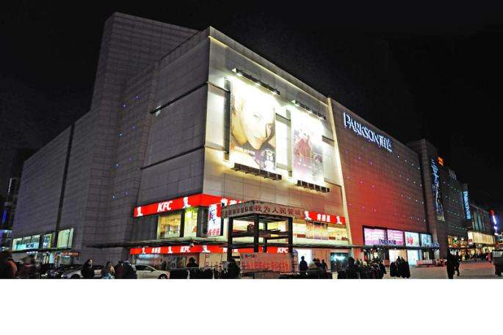

Meals
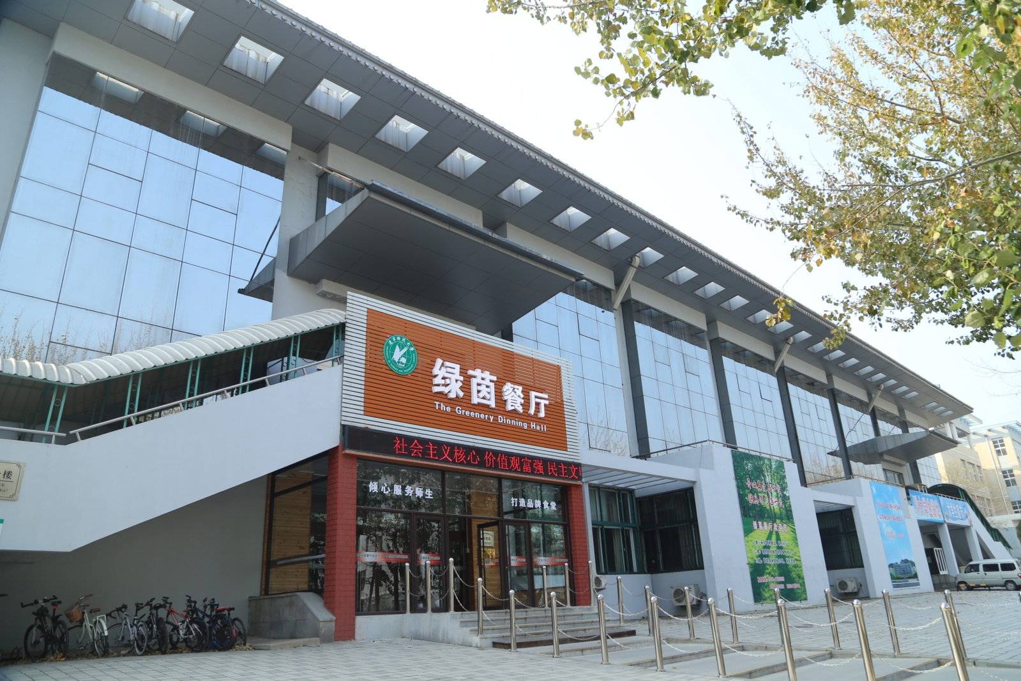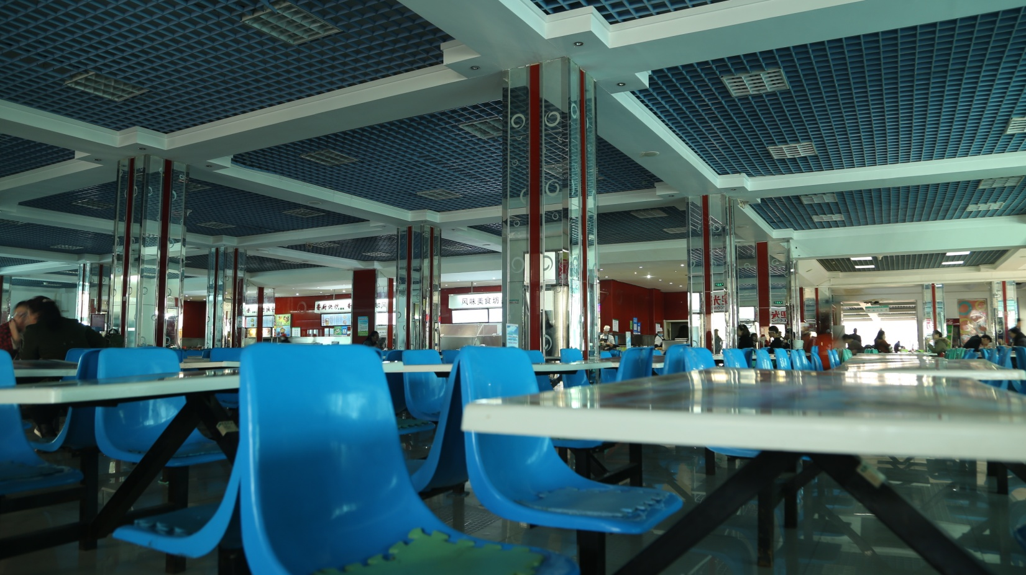

Living

Recreation and Sports
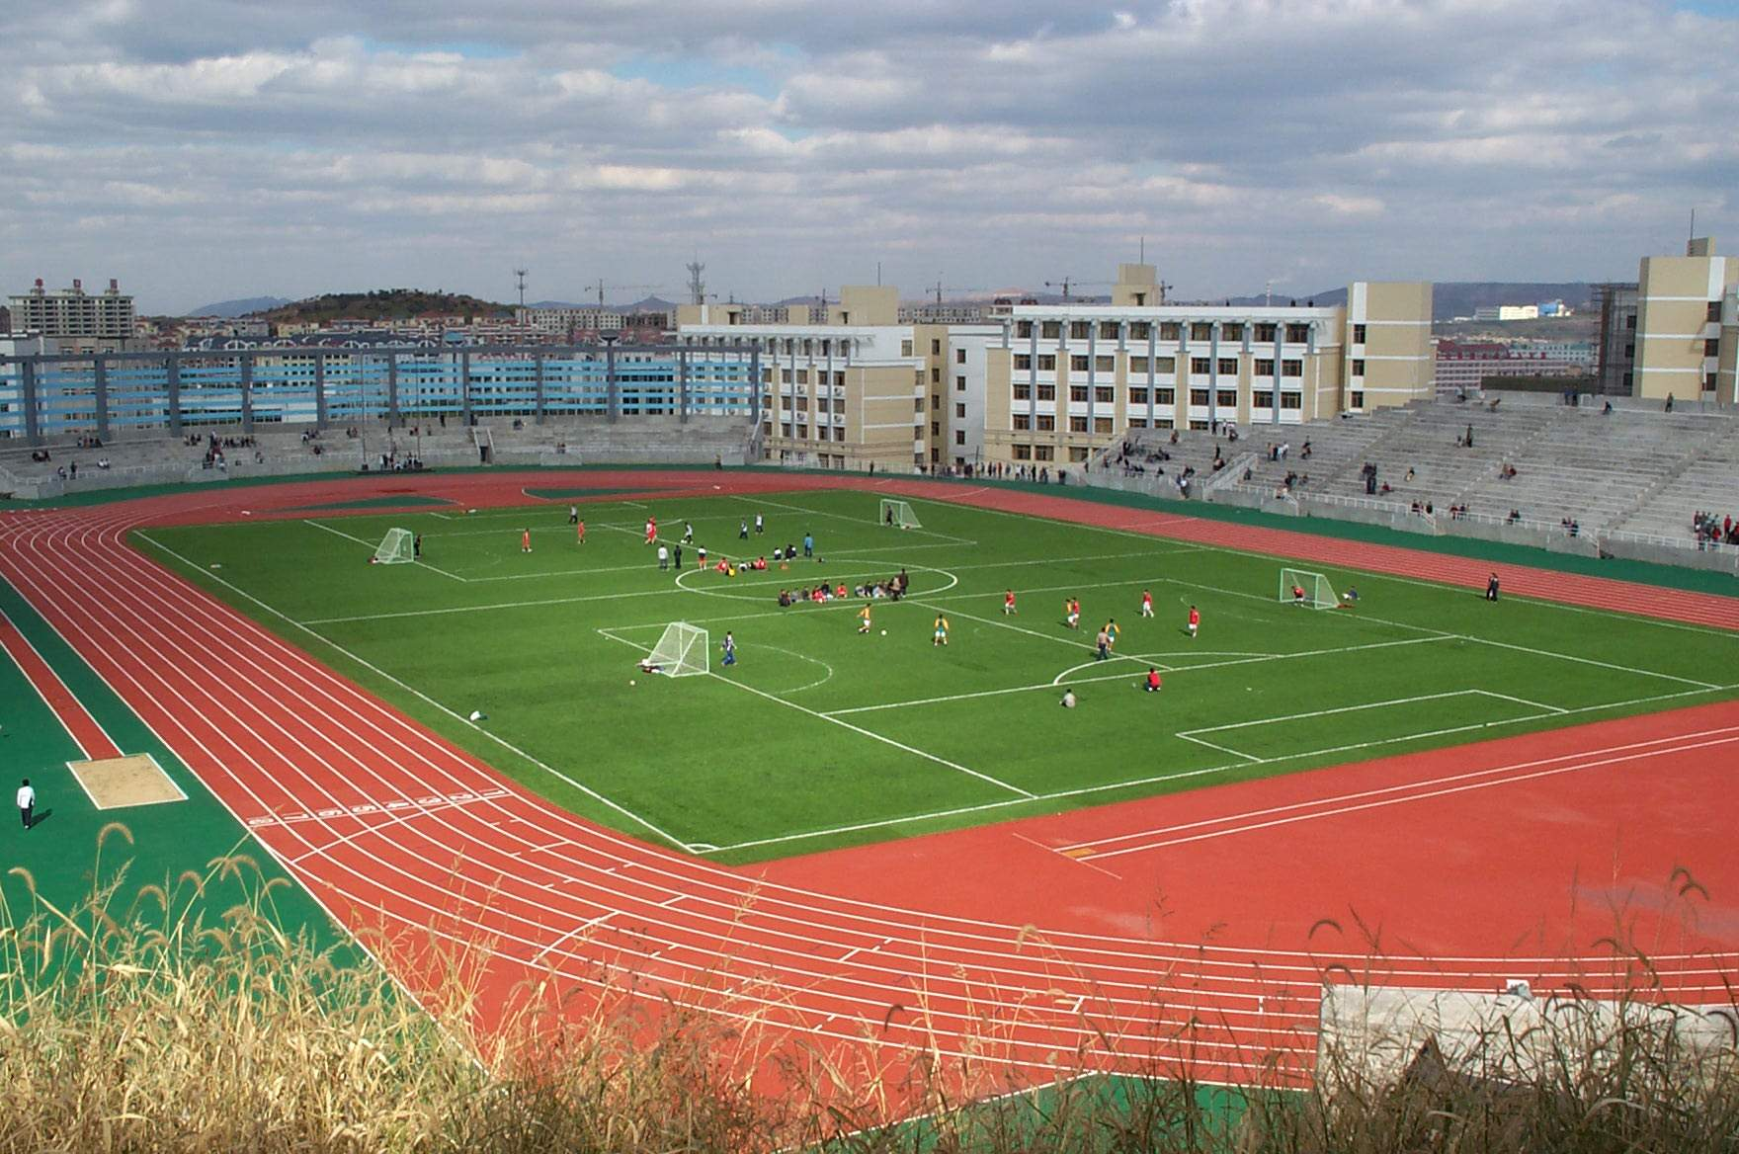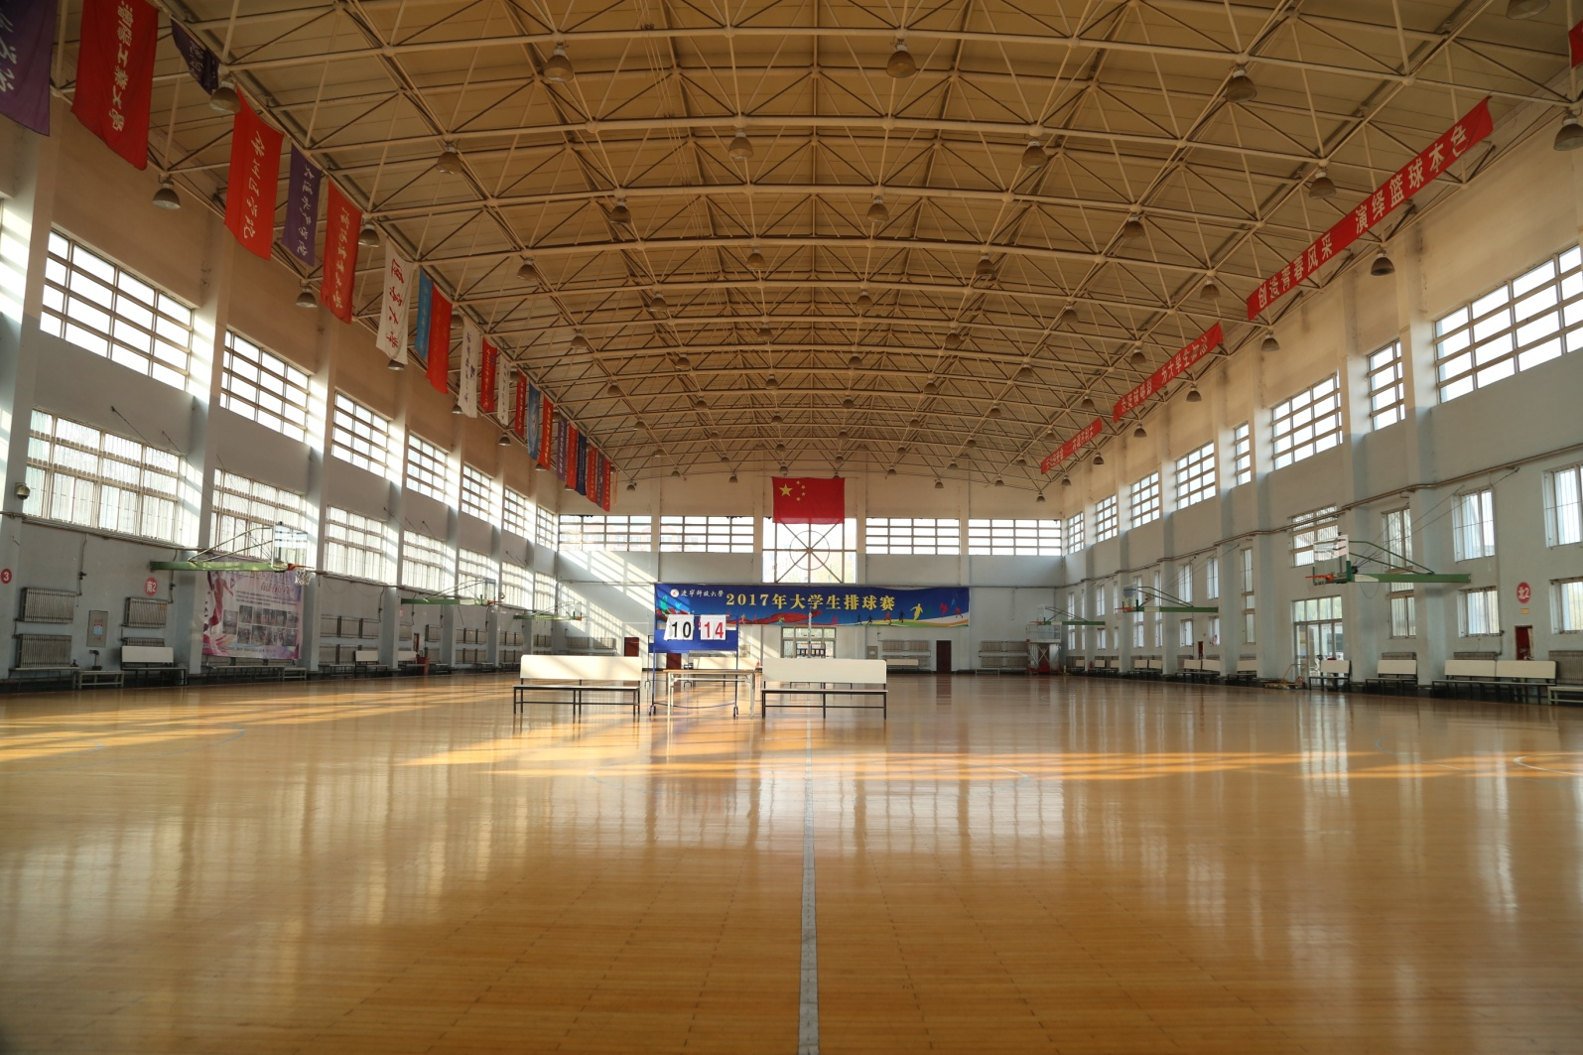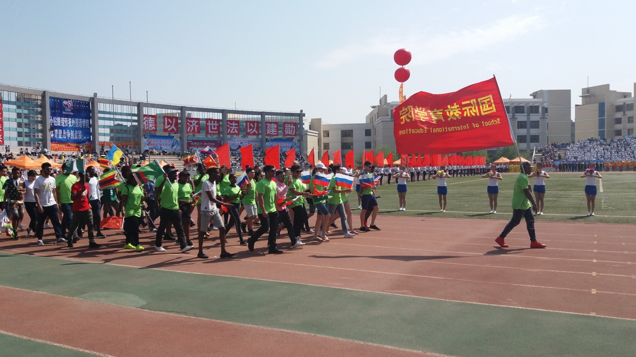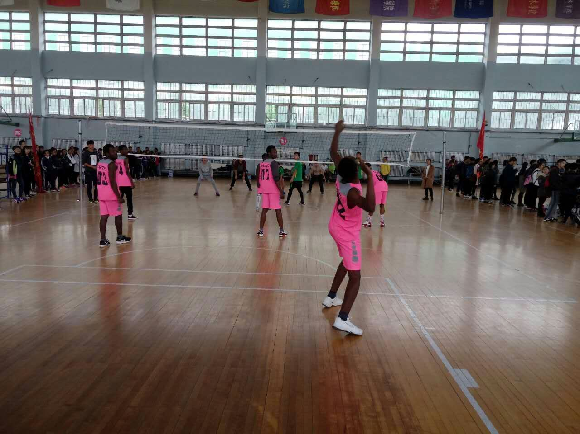
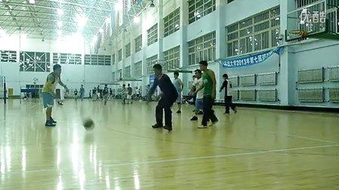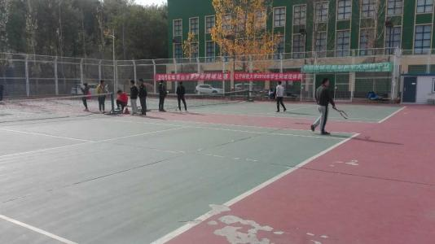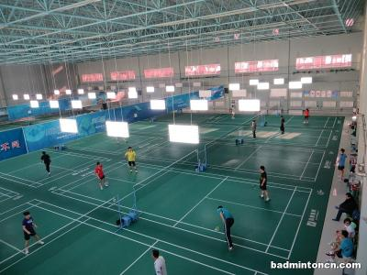

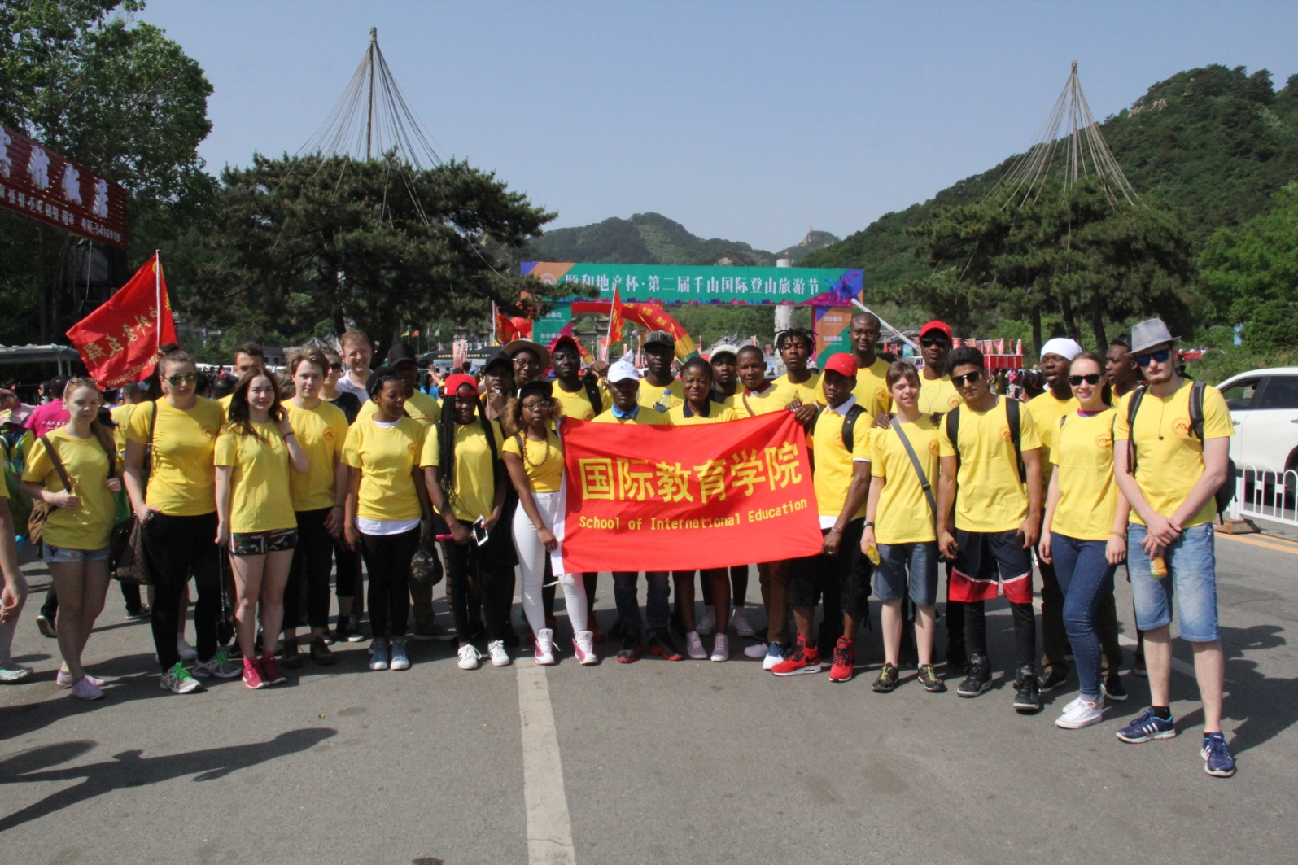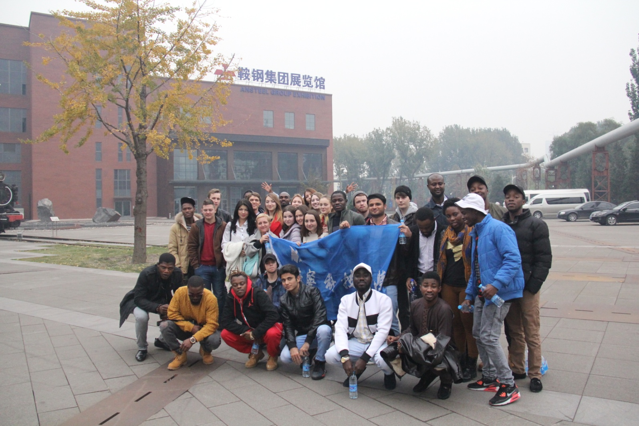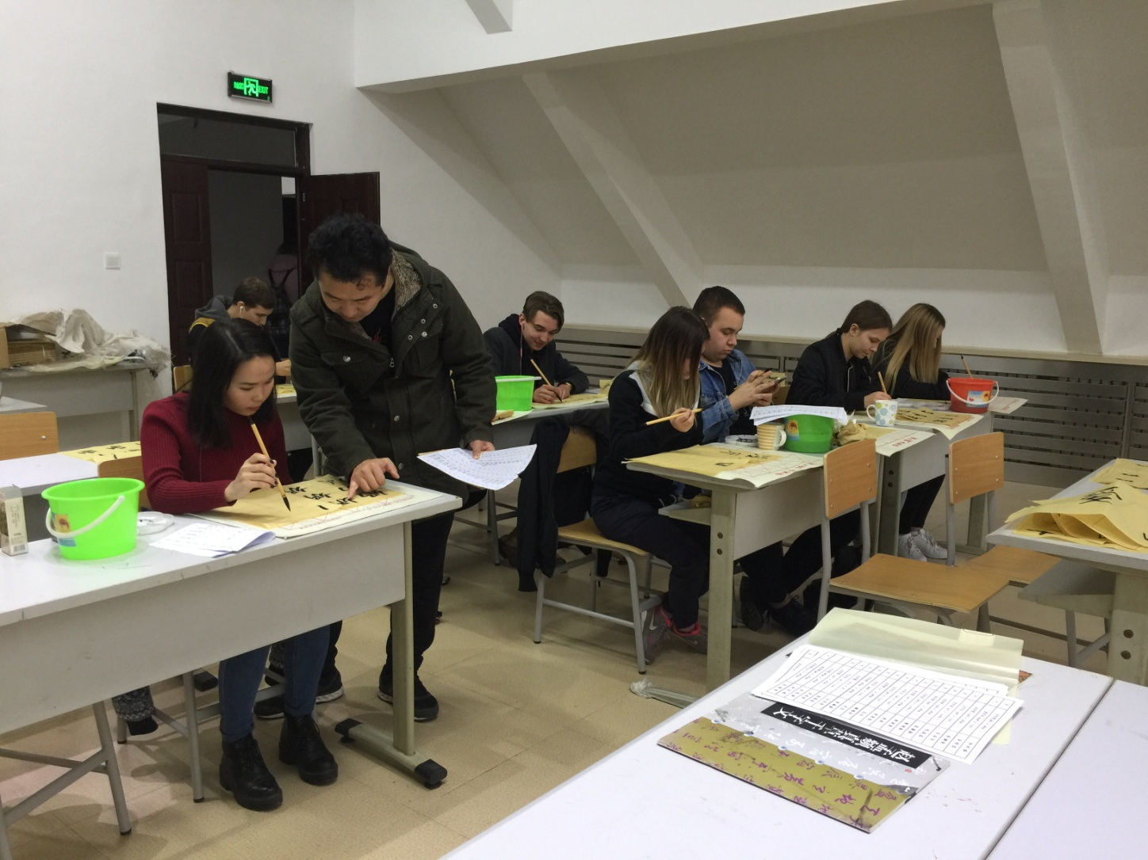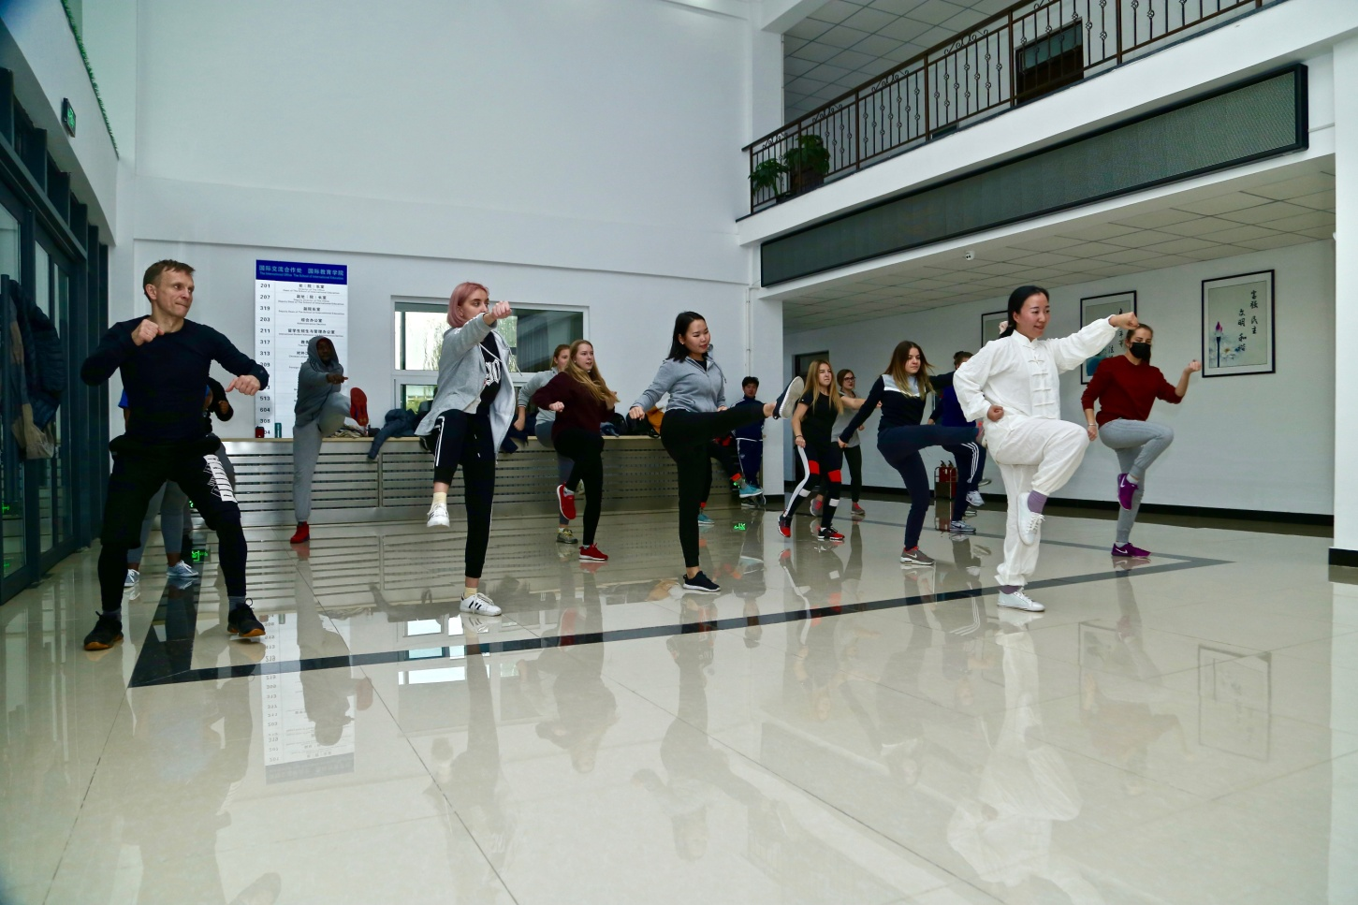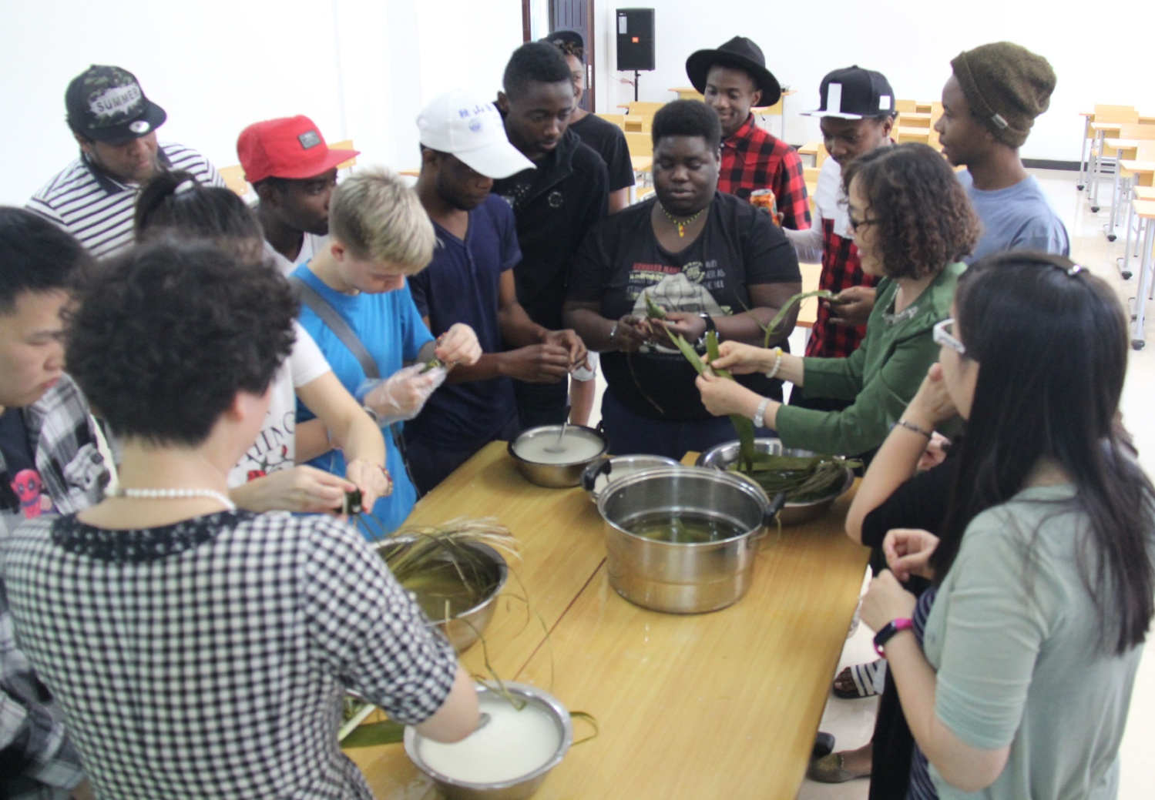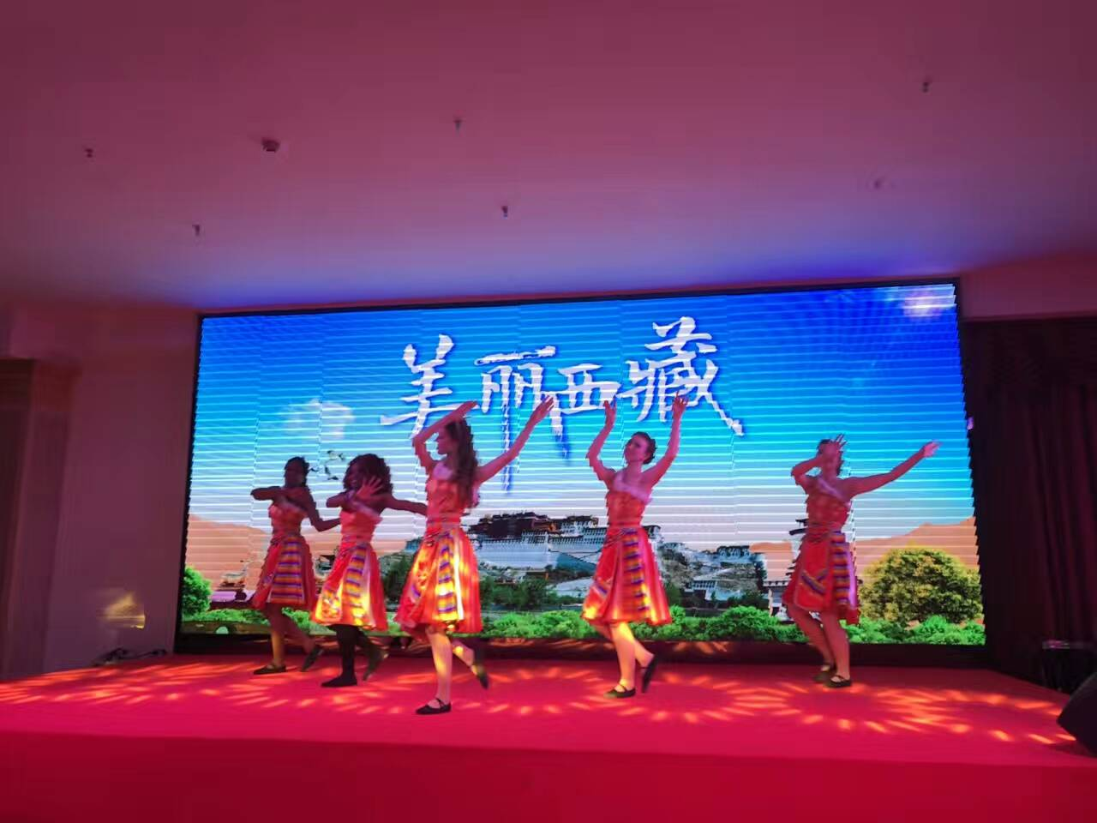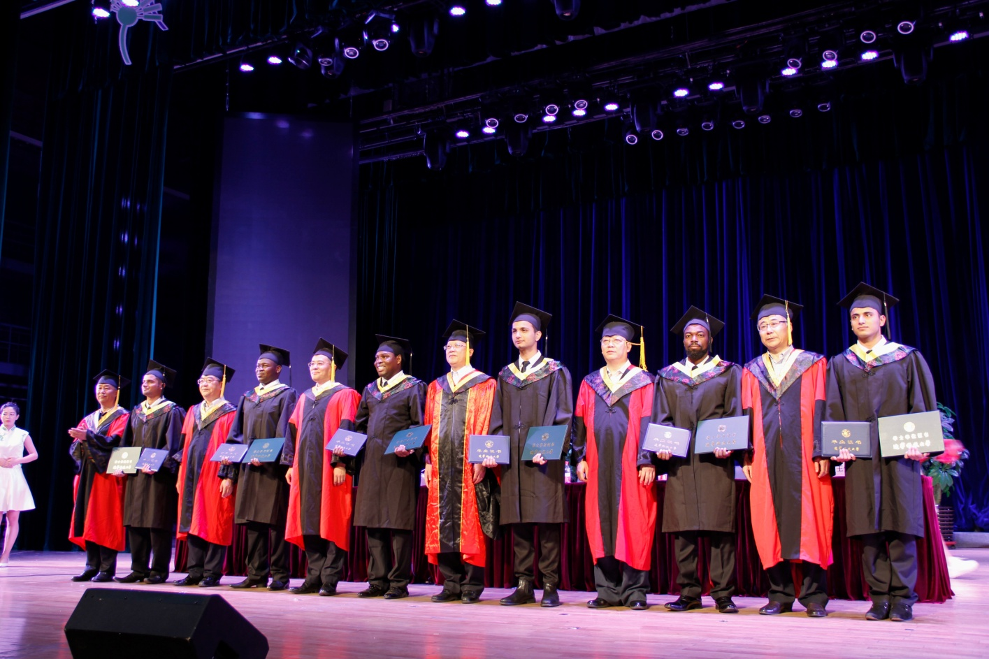

Travelling
Local Transportation
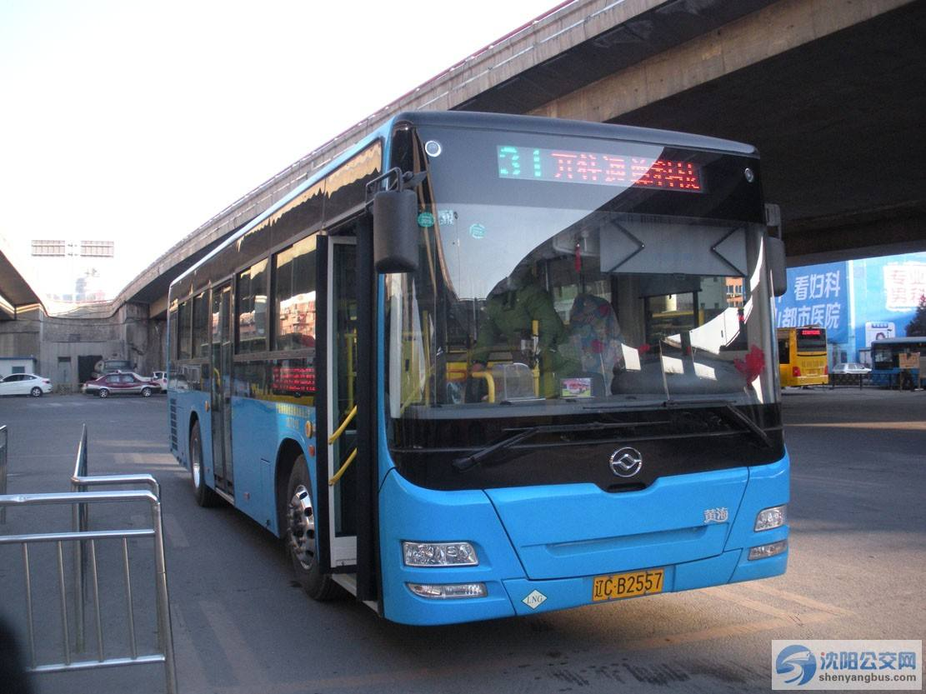
Intercity Traffic
The Economic Way
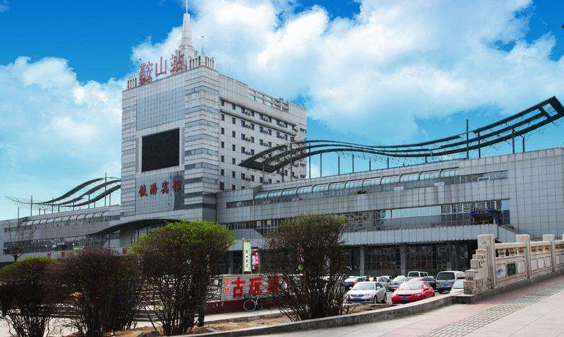
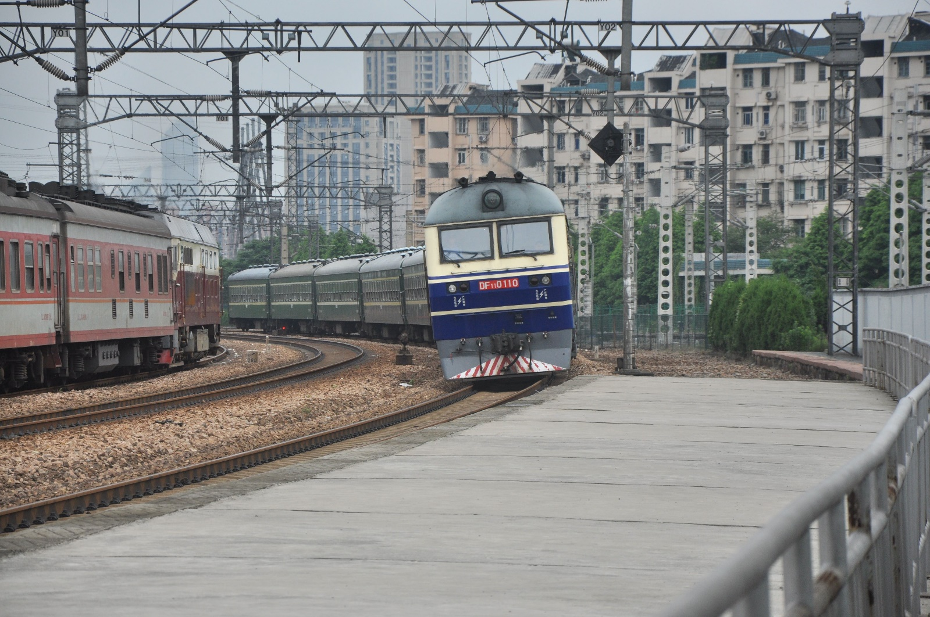

The Fast Way
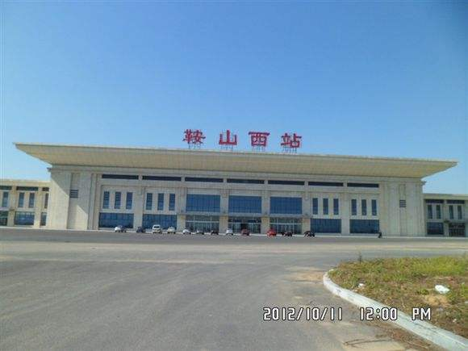
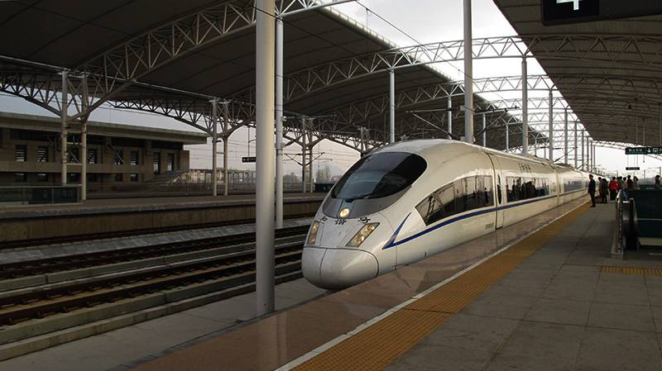
The Air Way
Anshan Tengao Airport
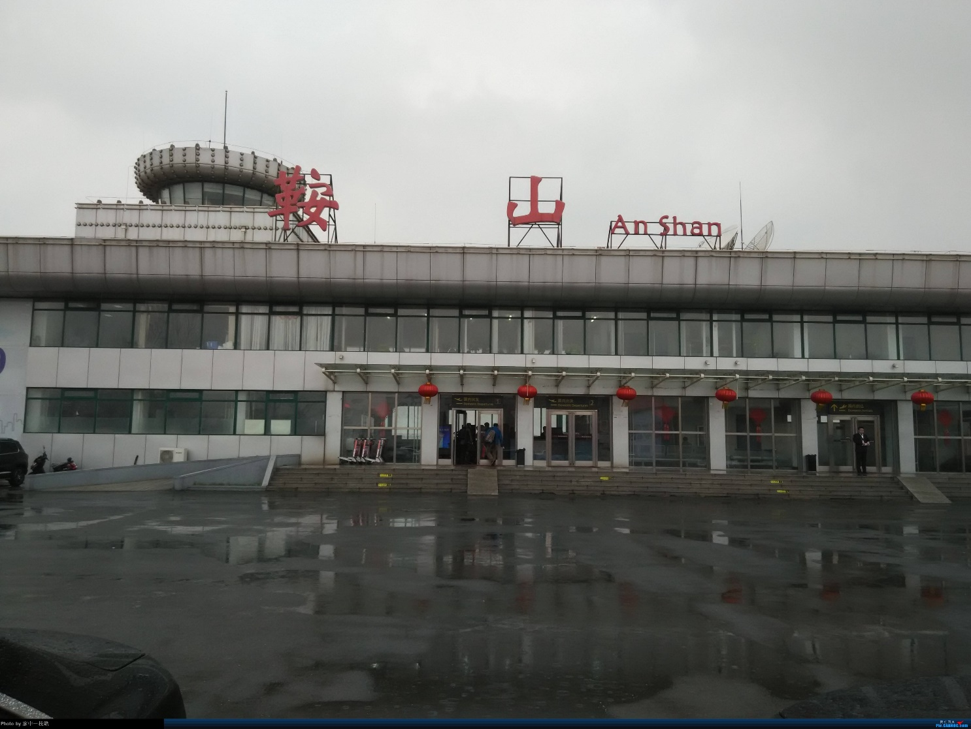
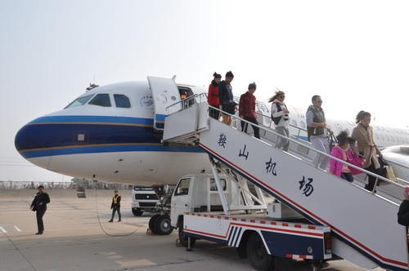
Shenyang Taoxian International Airport
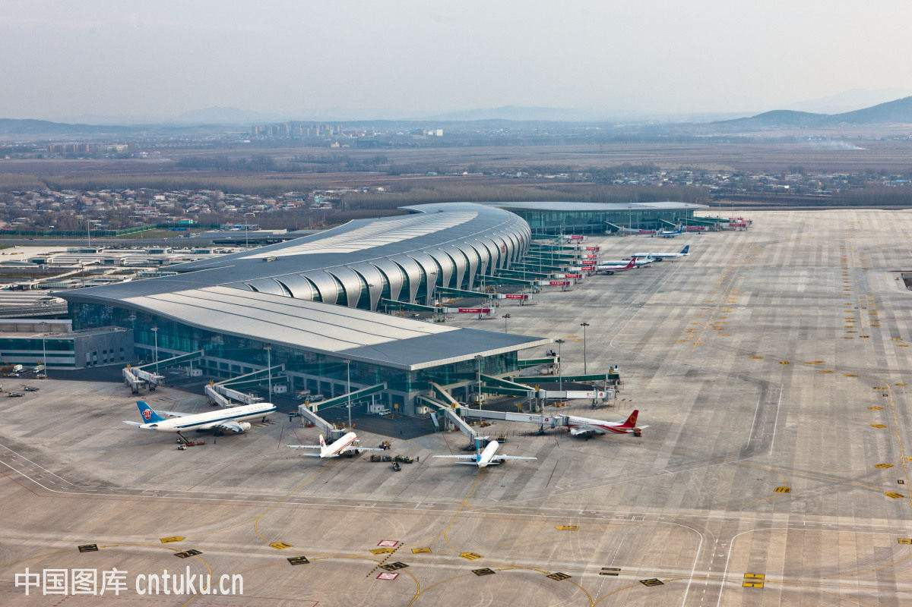

Appendix II: Abbreviations
ISR: International Student Regulations
ISCRS: International Student Credit Rating System
ISDR: International Student Dormitory Regulations
ISAO: International Student Affairs Office
TI: Trail Implementation
USTL: University of Science and Technology Liaoning
Student Card: It is the card that a student of the University can use for personal identification, meal and book borrowing across the campus.
Student Smart Card: It is the key card for a student’s room in International Student Dormitory
Student Certificate: It is a green small booklet that a international holds as the formal identification of registration.

